Online Food Ordering System

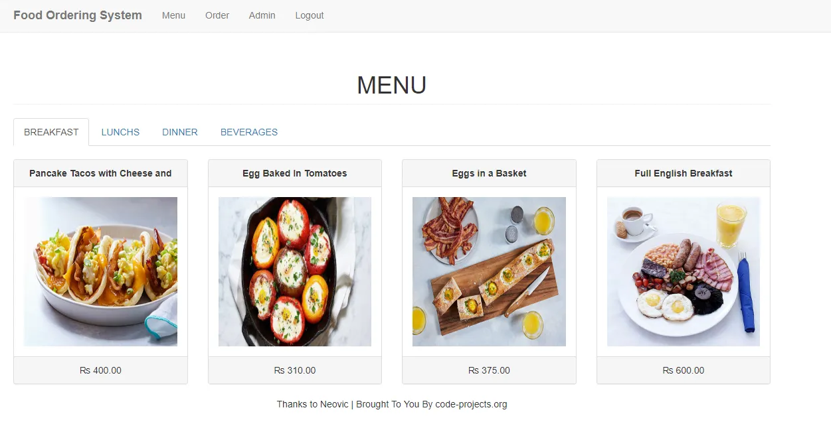
The Online Food ordering system in PHP source code is developed using PHP, Bootstrap, and JavaScript. The source code has the essential features required for an online food ordering system.
This project has an admin side where Admin can manage sales, products, categories, and food orders. The Admin plays an important role in the management of the system.
In this project, all the main functions are performed from the Admin side. The Admin has full control of the system, all the functions are to be performed from the Admin panel.

The functionality of Admin Side
Here, the admin can manage food orders easily. For this, the system displays available dishes with its name, photo, category, price, and the user has to enter the quantity and customer’s name.
All the food orders are listed in the sales section. Here in the sales section, the admin can view total sales bill of each and every food orders displaying with customer’s name, order date, and total amount.
The admin can manage the product according to their categories. In the Products section, the user can perform tasks like CRUD, which allows the user to add, update, delete and view product items.
It’s too simple to add a category, the user should only provide a name. The system displays all these products and categories inside the Main Menu, in a clean and responsive way.
The design of this project is very user-friendly. To run this project you must have installed virtual server i.e XAMPP on your pc (for Windows). If you are using ubuntu, follow the instruction on how to install xampp in this site : https://vitux.com/how-to-install-xampp-on-your-ubuntu-18-04-lts-system/

Features of Fast Online Food Ordering System in PHP

Online Food Ordering System Project in PHP Features:
- Accept online payments
- Orders received will automatically print to the printer
- Customers can order from a mobile, tablet or pc
- Edit menus, categories and pricing in real-time
- Display your menu and prices online
- Specify operating hours for online orders
- Food reservation at any desired schedule
- Hide unavailable products for delivery
- Offer customers the choice of eat-in/delivery
- Display the estimated preparation time for online orders
- Detailed statistics including daily sales totals and more
- Setup multiple stores and control them all from one system

